This is an interesting Topic

And this could be your work’s subtitle

Submitted by  to the | Your Name (Student No)  Chair of Ship Design
of the faculty | Fakultät für Maschinenbau und Schiffstechnik
at the | University of Rostock
Processing Period | 20 Weeks
1st Supervisor: | Prof. Dr.-Ing- Florian Sprenger  Albert-Einstein-Straße 2  18059 Rostock
2nd Supervisor: | John Doe, M.Sc.  Street not found 404  11100 Mytery City
Rostock: | Official submission deadline
Master’s Thesis
University of Rostock
Acknowledgements
Bachelorarbeit | Master
Fakultät
Put in your acknowledgements here if you like.

Abstract
Don’t write this in the last 5 minutes! A good abstract will help getting the attention this work deserves.

- Table of contents
1. Introduction 8
1.1 Tipps 8
1.1.1 Seitenlayout/Silbentrennung 8
1.1.2 Abstände vor und nach den Überschriften 9
1.1.3 Grafik im Text 9
1.1.4 Überschriften für das Inhaltsverzeichnis 10
1.1.5 Change font templates 10
1.1.6 Page borders 11
1.1.7 Footnotes 11
1.1.8 Create equations 11
1.1.9 Reference Equations 12
1.1.10 Page numbers 12
1.1.11 Table of contents 12
1.1.12 Tables 12
1.1.13 Header 13
1.1.14 Section breaks 13
1.1.14.1 Why do I need these 13
1.1.14.2 How to create a section break? 14
1.1.14.3 What is my current section? 14
1.1.15 Create a .pdf-file, what do I have to do? 15
1.1.16 Write table of contents into the pdf as bookmarks 16
1.1.17 Create Abbreviation as Index 18
1.1.18 Insert list of abbreviations 18
2. Some further handy hints 19
2.1 TBA 19
3. New Chapter 20
4. Conclusion and Outlook 21
Bibliography 22
A. First Appendix 23
Declaration of Authorship 24

- List of figures
Figure 1: Create a section break 14
Figure 1-2: This is how to show sections 14
Figure 3: Activate display of current section (english language setting shows "section" instead of "Abschnitt") 15
Figure 4: Word options for embedding fonts 15
Figure 5: Check fonts in Acrobat reader 16
Figure 6: Transfer textmarks into the .pdf-File 16
Figure 7: Textmarks in the .pdf-File 17

- List of tables
Table 1: Caption should be placed above tables 12
Table 2: simple way to show some information 13
Table 3: University Blue 13

- List of Abbreviations
IMO
International Maritime Organization, 18

Introduction
This document structure complies with the guidelines for writing academic papers and contains some tips to help you with the writing process. The style templates comply with the specifications.
Structure of an academic thesis:
- Title
- Table of contents
Roman numbering
- List of figures
- List of tables
- Further lists (LoFormulas/LoAbbreviations)
- Main part (text) of the thesis
Arabic numbering
- Bibliography
Roman numbering
- Declaration of Authorship
- Restriction notice

Tips
Save your document in multiple stages and multiple locations (or use modern storage solutions with automatic backup and versioning).
Your personal network drive (\\nvs1.uni-rostock.de) contains a versioning and daily backups. This enables access to prior versions in case of file problems.
Every student can use 200 Gb of storage there.
Remember to arrange for printing of your thesis well in advance. Allow sufficient time for this. Please also refer to the instructions for creating a PDF file.

Spaces before and after headings
The spacing before and after headings is already defined in the heading style templates. Do not insert any additional blank lines. If you do not like the spacing, change it in the style templates.

Graphics in text
If you need to include a lot of graphics in your work, check the setting in the File, Options, Advanced menu:
By default, Word converts each graphic to 220 ppi when it is inserted. If you do not want this to happen, click “Do not compress images in file.” This will preserve the resolution and increase the file size.
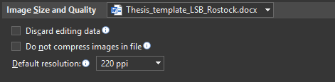
Insert graphics and figures only using the „InsertPictures“ menu. Afterwards assign a caption using right-click menu. Don’t scale pictures without blocking the aspect ratio (besides looking weird, this can lead to .pdf export problems).

Change font templates
Move your cursor tot he specific font template and select „modify“ by right-clicking. Changes propagate through all places, where this preset is used automatically.

Page borders
The page borders are 2,5 cm both above and below text as well as 4 cm (left) and 3 cm (right).Die Ränder betragen oben und unten 2,5cm, links 4cm und rechts 3cm. Change these settings using the menu “Layout Margins”.

Footnotes
Footnotes are vreated in 10 pt font sizew. You can add some spacing between footnote number and description using tab. This is advantageous for multi-row footnotes (refer footnote 2).

Create equations
Formulas are added using menu “insert equation”.
$$c_{B}=\frac{∇}{L_{PP}⋅B⋅T}$$
If you like to have numbered equations, you can type “#()” directly in the equation editor. This will add a box inside brackets at the right side of the page after the equation. DO NOT insert a plain number here, but prepare for automatic numbering. For that purpose, this template comes with a custom field named “eq” counting the equations. This will result in the following type.
$$\begin{aligned}P_{E}=R_{T}⋅v_{s}\#\left( seq eq 1\right)\end{aligned}$$

To do this, move the cursor inside the brackets, then type strg+f9 (Windows) or cmd+f9 (mac) which will create curly special brackets (just typing curly brackets will NOT WROK). Inside these brackets type “seq eq” and hit f9 to update/create the number. To get the following equation, therefore type the following in the furmula editor: a = b #(). Then move cursor in the created box on the right strg+f9 type “seq eq” f9.
$$\begin{aligned}a=b\#\left( seq eq 2\right)\end{aligned}$$
The numbering of newly inserted equations will increase automatically. However, if you place it before the first equation, both will get number (1). To fix this: select all equations (or whole text using strg+a) and right-click to one equation’s numbering for selecting “update field”.

Reference Equations
To cross-reference equations, you have to create a bookmark for this (same as label in LaTeX). For this purpose, mark the equation’s number (it has to be a field-value) and select meu “insertbookmark”.
$$\begin{aligned}\overline{GM}=\overline{KB}+\overline{BM}-\overline{KG}\#\left( seq eq 3\right)\end{aligned}$$
Select a meaningful name (e.g. “eq_metacentricHeight”), hit enter and refer to Eq. ($3$) using menu “References”Cross-Reference.

Page numbers
Page numbers appear at the top-right corner. If you want to end a page and move to the next page, use strg+enter. DO NOT USE multiple enter as these new lines will always shift down when new text is created.

Table of contents
The TOC is placed behind the title page and acknowledgement and abtract. All titles of heading_1 to heading_4 are included. To update, select the specific option using right-click.

Tables
Tables are created using menu „insert“ Table.
To select the whole table, move the cursor to the top-left corner until a cross-icon appears. Here you can also right-click to insert a caption.
If you like to add a new row at the end of the table, just use the tab-key.

Table 1: Caption should be placed above tables
Name | Course | B
Schmitt | A1 | B1
Paul | A2 | B2
Table templates can be customized individually. Typing inside the table adds new menu ribbons (Table Design and Layout).
Here you can choose from one of the templates or save an already used one as new template.

Table 2: simple way to show some information
Ship | Length [m] | Beam [m]
Linah | 368.52 | 51
Berlin Express | 399.9 | 61.00
Olympic Leopard | 339.76 | 60.04

Table 3: University Blue
Name | Table-template | Centered
ggg | test
aaa

Header
The header includes the title oft he current section written in Heading_1. In the section of list of tables and figures it instead uses Heading_roman. You can change it according to your needs. It can help to display how this is done by switching the view option back and forth using alt+f9.

Section breaks

Why do I need these
Section breaks are always necessary if new formats are introduced that are independent from the other text. Examples:
- Page orientation should be swithced from portrait to landscapeE
- Page numbers should be hidden on one or multiple pages.

If your text contains only one section, you are always workling in portrait OR landscape. Changing settings will change the whole document.

How to create a section break?
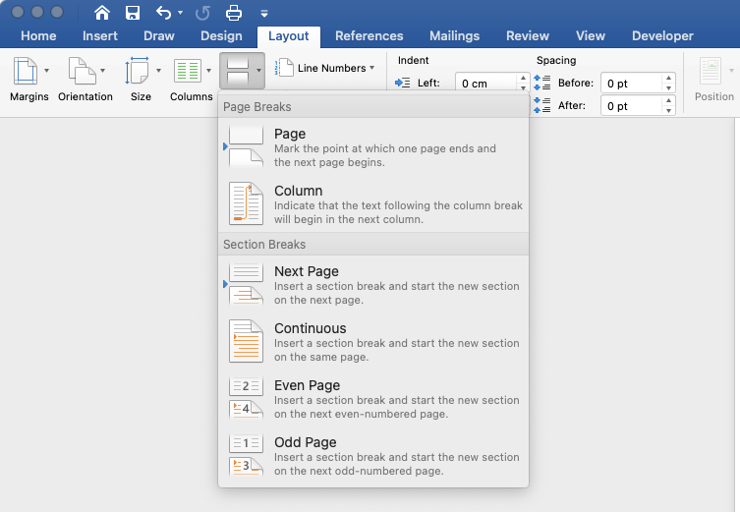
Figure 1: Create a section break

When inserting a continuos section break, this will be added ad the current cursor position. Often it is better to create the section break at the next page, because format options as page numberings belong to specific pages.

What is my current section?
Your current section is displayed at the lower-left window corner.
Figure 1-2: This is how to show sections
In case this information is missing, hover over the status bar and activate showing sections using right-click.

Create a .pdf-file, what do I have to do?
To print your thesis, in most cases you’ll have to export a pdf file. This functionality can be found in File save as pdf (Best for printing).
There are a few things to keep in mind when creating PDFs in Word:
In menu“fileoptionsSave“ you should specify settings as follows:
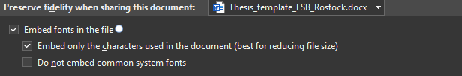

Check that the fonts are embedded in your PDF file.
In Adobe Reader or Adobe Acrobat, you can view the embedded fonts in the File menu under Properties. If one or more fonts have not been embedded, you must change this, as otherwise errors may occur during printing!

Write table of contents into the pdf as bookmarks
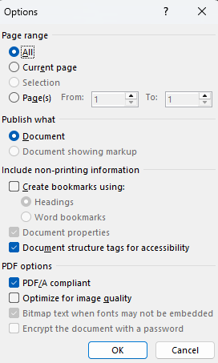
Figure 6: Transfer textmarks into the .pdf-File
Activate “Create bookmarks using headings” and you will have a clickable table of contents in the PDF file.
The PDF option “PDF/A compliant” creates a PDF/A document. No changes can be made to this PDF file without saving it under a new name.
Create Abbreviation as Index
- All Abbreviations have to be indexed.
- At first occurrence, select abbreviation (e.g. IMO (International Maritime Organization)
- Press alt+shift+x (Windows only) or go to menu “references” “mark entry”
- Main entry: insert abbreviation (e.g. IMO)
- Subentry: insert meaning (e.g. International Maritime Organization)
- Repeat for all abbreviations

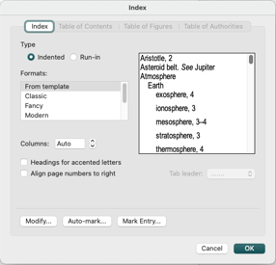
Insert list of abbreviations
- Put cursor at desired position (e.g. after title “List of abbreviations”)
- Select “Insert Index”, choose format and click ok

Some further handy hints
This is a collection of tipps&tricks for using MS Word when writing your scientific theses.

TBA
If you have some hints what we should include, just pass an email at iven.topp@uni-rostock.de.

New Chapter
Start with your own writing …

Conclusion and Outlook
What was achieved, what is do be done…

Bibliography
Sprenger, F. (2024). How to write - Guide for the preparation of scientific texts.
Bronsart, R. (2013). Damaged Stabilty & Roll Motions in Waves - in a nutshell.

In Word you can add sources and include a bibliography as shown above. However, the integration of a literature management tool (e.g. citavi) is recommended

- First Appendix

Declaration of Authorship

I declare that this thesis and the work presented in it are my own and have been generated by me as the result of my own original research.

Where I have consulted the published work of others, this is always clearly attributed.

Where I have quoted from the work of others, the source is always given. With the exception of such quotations, this thesis is entirely my own work.

I have acknowledged all main sources of help.

Where the thesis is based on work done by myself jointly with others, I have made clear exactly what was done by others and what I have contributed myself.

This thesis contains no material that has been submitted previously, in whole or in part, for the award of any other academic degree or diploma.

I cede copyright of the thesis in favour of the University of Rostock.

Date: ________________________ Signature: ________________________

This is a footnote
This is also a footnote. For long footnotes the footnote text is formatted using tab in a way, that some indentation is added.

